RULES  This Competition will be run in accordance with British Riding Club Rules for Competitions, BRC Handbook 2004. page 79 ref,A/E.  Entry is open to all affiliated Riding Clubs in Area 17. Competitors only, are permitted to ride the horse on the show ground.  British Riding Clubs, Moreton Equestrian Centre and persons acting on their behalf, do not accept any liability for any loss, accident or damage to any person, animal, vehicle or goods occurring in connection with this event. It is a condition of entry that each competitor indemnifies the organiser against any claim.  Whilst mounted, competitors must wear the correct riding clothes, which includes ‘Protective Headwear’, with a harness properly adjusted and fastened, also wearing your number, Failure to do so may incur elimination. ‘Protective Headwear’ constitutes a hat meeting one of the following standards, and has been tagged with the PINK tag. Hats can be checked at the steward in the “LOG CABIN”  British PAS 015: 2011 ~ Must have BSI Kitemarked or IC Mark  European VG1 01.040: 2014-12 or Inspec IC mark  American ASTM F1163:2004a or 04a onwards ~ Provided they are SEI marked. SNELL E2016 onwards official Snell label & no.  Australian & New Zealand AS/NZS 3838 2006 onwards ~ Provided they are SAI Global marked  Competitors must report to the ring steward and be ready to ride up to 10 minutes before the allotted time.  VACCINATIONS: The Passport/vaccination Certificate must, under penalty of elimination, accompany the horse to all official competitions, the competitor is responsible for producing it on demand .YEARLY VACCINATION.  HEALTH AND SAFETY : The organisers and land owners have taken all reasonable precautions to ensure the health and safety of everyone present. for these measures to be effective, everyone must obey the instructions of the organisers, officials and stewards, and take reasonable precautions to avoid and prevent accidents occurring.  Horses or ponies must not be tied up outside boxes or trailers and left unattended,  Dogs must be kept on short leads at all times.  Body protectors now 2018 BLACK/BLUE labels ONLY not PURPLE 2009 | 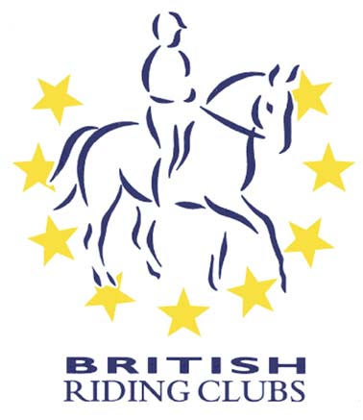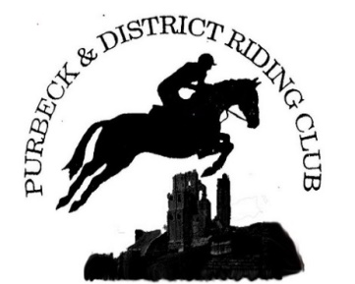  PURBECK & DISTRICT  Riding Club  Area 17 Arena Eventing Qualifier for the 2024 Championships sponsored by  Sunday 21st April 2024  At Moreton Equestrian Centre  Moreton, Dorchester, Dorset DT2 8RG  Organiser Bob Mael :- mob 07559 219406  Official Steward Penny Towers  Course Builder Sarah Whittington , also Judge  First Aid Collingwood Services Ltd  Refreshments Dorset Farm Foods:- 07979 151730  Photographer Dorset Event Photos  Vet on Call Veterinary will NOT be in attendance .
The course consists of show jumps immediately followed by cross country fences, and will finish with the last fence as a show jump, the joker fence, which will be set at a discretionary 10cm higher than the rest of the course.  HORSES WILL BE PERMITTED TO COMPETE IN 2 CONSEQUTIVE CLASSES  CLASS 1: 70cm (340mpm) Juniors (New) for teams of four riders. The three best scores to count for the team and for individual placings  CLASS 2 : 70cm (340mpm) Seniors (New) for teams of four riders, the best three scores to count and for individual placings.  CLASS 3 : 80cm (350mpm) Juniors - for teams for four riders, the best three scores to count and for individual placings.  CLASS 4 : 80cm (350mpm) Senior - for teams for four riders, the best three scores to count and for individual placings.  CLASS 5 : 90cm (360mpm) Mixed Class (New) - for teams for four riders, the best three scores to count and for individuals.  CLASS 6 : 100cm (375mpm) Mixed class - open to senior and junior teams and individuals, teams may be a combination of senior and/or junior. The three best scores to count and for individual placings  PLEASE ENSURE YOU FAMILIARISE YOURSELF WITH THE RULES IN THE CURRENT B.R.C. RULE BOOK 2024 :- page 79 for ARENA EVENTING  Page 102-103 for TACK rules Page 90 for ELIGIBILITY  Page 70-81 for ARENA EVENTING rules & scoring  Page 97-99 for Speeds & jumping efforts  The Championships for the ARENA EVENTING are now to be held at  Aston Le Walls on the weekend of the 31st May to 2ndJune 2024  Medical arm bands are strongly recommended and must be properly completed with the relevant competitors details and worn on the arm  Stop watches are NOT permitted  Please print your own numbers. | PRE- ENTRIES:- BRC Office, online LATEST. Friday 22nd March 2024.  Prelim and Detailed entry forms are available from BRC web site  DETAILED ENTRIES, no later than 10th April 2024.  Please e-mail to :- r.mael@btinternet.com  Bob Mael, Rushcombe Farm, Higher Blandford Road,  Corfe Mullen, WIMBORNE, Dorset, BH21 3JF  TEAM MANAGERS MUST ensure ALL horse passports are CORRECT and on the Area 17 database before submitting their team entries,  Payments to be made by Clubs only by BACS to :-  PDRC-AE:- Sort code 30-96-73. Acc.no 62499260 For the reference please add your club name plus AE. Please advise the secretary by e-mail when payment has been made :- vkp56@hotmail.co.uk  ENTRY FEES:- All Classes:- £20 individual (£80 Team).  Plus FIRST-AID fee of £3.50 per rider (regardless of number of classes)  TIMES : Will be on the website:- www.ridingclubresults.co.uk  By latest Thursday 18th April 2024.  SUBSTITUTIONS : In the event of withdrawals or changes, substitutions will be allowed. The deadline for complex substitutions will be Wednesday 17th April 2024 by 1800hrs via email or phone to Bob Mael (07595 219406)  A complex substitution is one where teams are re-arranged or horse/riders moved from one team to another. Simple replacements of horse and rider in a team can be done up until time of declaration.  DECLARATIONS : must be made by team managers at least 30 mins before the start of the class.  HEALTH AND SAFTY: The organisers of this competition have taken reasonable precautions to ensure the health and safety of everyone present, For these measures to be effective everyone must take all reasonable precautions to avoid and prevent accidents occurring, and must obey the instructions of officials and stewards.  HAT TAGGING :- Hats must be tagged (PINK is current colour) before competitors will be allowed to ride.(Checking in log cabin)  BODY PROTECTORS ARE COMPULSORY. From 1st January 2024. BRC will no longer accept 2009 Purple labels. Now 2018 Black/Blue Labels

