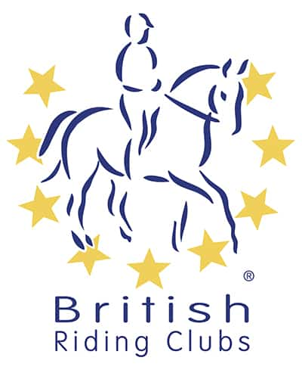
BRC AREA 17
Winter
Show Jumping Qualifier
organised by New Forest Riding Club
Section A of each class at this event are qualifiers for the BRC Novice Winter Championships (6-7 April 2024) and Intermediate Winter Championships (27-28 April 2024) – BRC Members only
BRC Area 17 Members and Pony Club Members only event
Sunday 18th February 2024
at
Crofton Manor Equestrian Centre
Official Steward: Penny Towers
Course Builder: Becky Stansfield
Paramedic: Collingwood Services
Photographer: Simply Event Photos
Vet on Call
Catering: Crofton

ORGANISER and ENTRIES SECRETARY:
Amy Robbins
07803537369 (after 5pm only)
amy.robbins@hotmail.co.uk
17 Green Close, Whiteparish, Salisbury, SP5 2SB

PRELIM entries to BRC for qualifying sections/competitors close on Friday 26th January via the online portal: British Riding Clubs - Login (bhs.org.uk)
AREA and open PC/RC Members entries close Tuesday 13th February entry forms can be found with this email or on the BRC Area 17 website.

Times will be emailed to Team Managers and will be available on the
Area 17 website by 7pm Thursday 15th February
http://www.area17-brc.org.uk/
Course walk, warm up and start times will be clearly stated when the rider times are published

Passport copies of all horses in qualifying classes must be up to date and held on the Area 17 Database by entry closing date. Flu vaccination record must comply with the 2024 updated policy in section G7.1 of the handbook, currently only needing annual vaccinations (plus the initial three). This will be checked to ensure that each horse is on the shared drive and accepted by 26th January 2024.
PLEASE REMOVE AND TAKE HOME ANY LITTER AND ALL DROPPINGS/HAY LEFT BY YOUR HORSE AROUND YOUR VEHICLE

Schedule
All competitors will jump one round (SJ1.0.1: QUALIFIER FORMAT - Option 1- 1 round following straight onto a jump-off, with all competitors going forward to the jump-off section.). Heights will run consecutively to allow competitors to enter two heights on the same horse if they wish (full rule below). All classes to run inside.

Class 1 |  | 60cm open class (not qualifier) open to all members of riding clubs and pony clubs
 |  | Entry Fee £40 Team, £12 individual.
Class 2 |  | 70cm
Section A |  | Qualifying Junior or Senior competitors
Section B |  | Non-Qualifying open to all members of riding clubs and pony clubs
Teams are either junior or senior, no combinations.
Entry Fee £40 Team, £12 individual.
Class 3 |  | 80cm
Section A |  | Qualifying Junior or Senior competitors
Section B |  | Non-Qualifying open to all members of riding clubs and pony clubs
Teams are either junior or senior, no combinations.
Entry Fee £40 Team, £12 individual.
Class 4 |  | 90cm
Section A |  | Qualifying Junior or Senior competitors
Section B |  | Non-Qualifying open to all members of riding clubs and pony clubs
Teams are either junior or senior, no combinations.
Entry Fee £40 Team, £12 individual.
Class 5 |  | 100cm
Section A |  | Qualifying Junior or Senior competitors
Section B |  | Non-Qualifying open to all members of riding clubs and pony clubs
Teams may be any combination of seniors or juniors
Entry Fee £40 Team, £12 individual.
Class 6 |  | 105cm
Section A |  | Qualifying Junior or Senior competitors
Section B |  | Non-Qualifying open to all members of riding clubs and pony clubs
Teams may be any combination of seniors or juniors
Entry Fee £40 Team, £12 individual.

Teams must either be all in Section A or all in Section B – There can be no mix of qualifying/non-qualifying members within the same team.

ELIGIBILITY REQUIREMENTS – ONLY APPLIES TO SECTION A
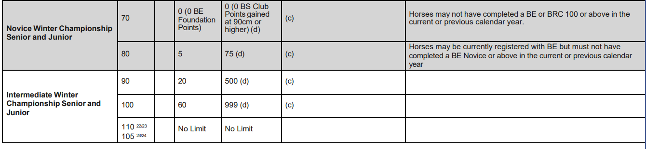
“HORSES BEING USE TWICE” in SHOWJUMPING
Refer to CR Appendix 3, page 100 of the BRC 2023 Handbook under Show Jumping.
A horse may now compete at consecutive heights in Show jumping, (For Example NOT 80 & then 100)
- 70 and 80
- 80 and 90
- 90 and 100
- 100 and 105
- Style Jumping – only permitted to compete once
Horses may only compete TWICE in show jumping classes. Horses may compete in teams OR as an individual in each height. Horses can only compete ONCE at a height except for a senior and junior sharing a horse at a competition.

TACK CHECK
All riders should present to the Tack Check Steward a minimum of 20 minutes before their time. It is the responsibility of the rider to ensure their tack and equipment conform to the rules. Full details are in the current BRC Handbook.

COMPETITOR NUMBERS
Competitors must provide their own back number or within a number bib clearly displayed on the back of the rider.

HELPERS
Each participating Club entering a team or multiple teams will be required to provide names and contact details of 1 helper (full day) or two helpers (half day). The Relevant form will be sent to each participating Club and must be returned with the area entry form.

ENTRIES
PRELIM entries to BRC for qualifying sections close on Friday 26th January via the online portal: British Riding Clubs - Login (bhs.org.uk)
AREA and open entries close Tuesday 13th February entry forms can be found with this email or on the BRC Area 17 website. completed and sent to Amy Robbins via email to amy.robbins@hotmail.co.uk.
Payment should be made via BACS to NEW FOREST RIDING CLUB,
sort code: 20-53-53 acc no: 40393835 reference: AREA SJ (insert club name).

SUBSTITUTIONS
In the event of withdrawals, substitutions will be allowed. The deadline for complex substitutions will by 12pm Thursday 15th February. Late simple substitutions can be made in writing up until 17th February, an on the day change should be verbalised on the day but substitution horses must have PASSED the passport check. A complex substitution is one where teams are re-arranged, or horse and rider combinations are moved from one team to another. Simple ones are where a horse and/or rider replace(s) the withdrawn one in the same team and position.

RULES

Dogs must be kept on short leads and under close control at all times.

This competition will be run in accordance with the official rules for all British Riding Club Competitions 2024. Area 17, New Forest Riding Club, and persons acting on their behalf, do not accept any liability for any loss, accident or damage to any person, animal, vehicle or goods occurring in connection with this event. It is a condition of entry that each competitor indemnifies the organiser against any claim.

To qualify for the relevant British Riding Club Championships, entries must be made through clubs on the official forms.
Competitors only are allowed to ride their horse on the showground. Everyone mounted must wear a hard hat with the harness adjusted and fastened.
Under BRC rules, any rider who has a fall from their horse anywhere on the showground must see the paramedic before remounting and follow their instructions. The paramedics decision is final. Any breach of this rule will be reported to the Official Steward. Team managers are responsible for making sure all riders understand and accept this rule.

The Passport/Vaccination Certificate must, under penalty of elimination, accompany the horse to all official competitions. The competitor is responsible for producing it on demand.

The Organisers of this competition have taken reasonable precautions to ensure the health and safety of everyone present. For these measures to be effective everyone must obey the instructions of the Organisers, Officials and Stewards and take all reasonable precautions to avoid and prevent accidents occurring. A Paramedic will be available, and the event will be run in line with BRC First Aid Rules.
It is a condition of entry that neither the Organisers nor Landowners nor their agents shall be held responsible for any loss, injury, damage to competitors, onlookers, their property, horses or ponies, howsoever caused.
The Organisers reserve the right to cancel the event, alter classes, judges, times or any other published information. In the event of cancellation, a proportion of entry fees will be retained for administration purposes.
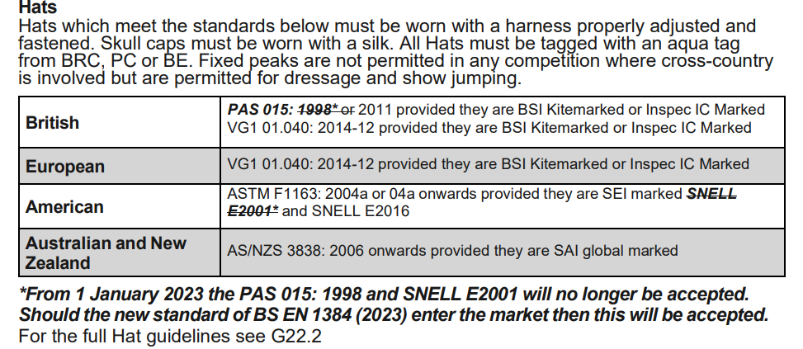
Protective headwear for all classes must comply with BRC rules 2024. All competitors in the qualifying classes must ensure their hat has been tagged by the Official Steward and carries the PINK tag. Accepted hat standards:

