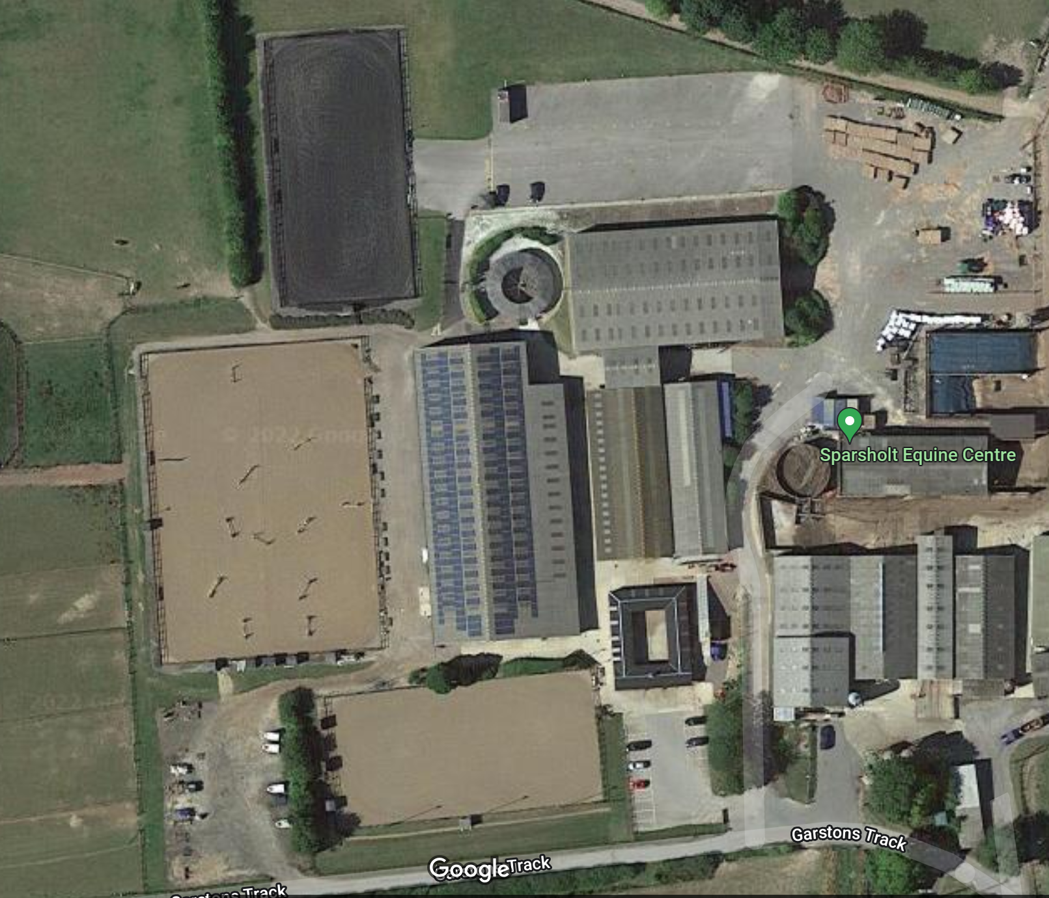

Car Parking

Lorry/Box Parking

Secretary

Tack Check

Tack Check

SJ Arena

DR Warm Up

DR Arena 1

DR Arena 2

SJ Warm Up

Judge/NFRC Parking