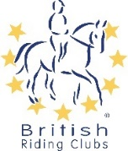 | British Riding Clubs  Non-Member COVID-19 Event  Declaration Form v2 August 2020 | 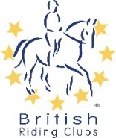

This form MUST be competed by each competitor, Team Manager or Event Helper for Track and Trace purposes.

EVENT: | Novice Winter Show Jumping Qualifier 2021
DATE: | 23/01/2021
CLASS ENTERED: | Click or tap here to enter text.
FULL NAME: | Click or tap here to enter text.
ADDRESS: | Click or tap here to enter text.
TELEPHONE NUMBER: | Click or tap here to enter text.
EMAIL: | Click or tap here to enter text.
NAME OF HELPER: | Click or tap here to enter text.
TELEPHONE NUMBER FOR HELPER: | Click or tap here to enter text.
By completing and submitting this form, I confirm I have read and agree to abide by the event rules in relation to this event. This includes any measures that are in place to make the activity COVID-secure.

I understand that any breach of these rules, will result in being asked to leave the site and may be subject to a ban from future British Riding Club activities.

Please Note: The event organiser will be holding these details for NHS Test and Trace purposes.

SIGNED:  (typing name is sufficient) | Click or tap here to enter text.
DATE: | Click or tap to enter a date.
FOR USE BY EVENT ORGANISER ONLY:
COMPETITOR NUMBER: | Click or tap here to enter text. | COMPETITOR TIMES: | Click or tap here to enter text.

