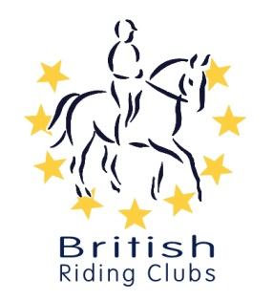

BRC AREA 17
COMPETITIONS

[Type a quote from the document or the summary of an interesting point. You can position the text box anywhere in the document. Use the Drawing Tools tab to change the formatting of the pull quote text box.]

BRC Area 17 teams sections at Moreton EC. Horse trials and Eventer Trial,

BRC Area 17 have teamed up with Moreton-Russell Ltd who have agreed to allow us to run BRC TEAM sections in their Unaffiliated horse trials this summer and the first will be the Eventer Trial (similar to FOTH Challenge) as part of their event on August 22nd 2020

Moreton have the experience of running out FOTH Challenge Qualifiers.
This will consist of S/Jumping on grass, then directly on to the x/country over Moreton’s BE course. So, similar to the original BRC Event but NOT Affiliated.
This means NO pre-entry fees to pay, just the normal entry fee to Sue Russell by EQUO on-line entry.

Please ask your members to enter as individuals on EQUO when the entries open, (I believe on 27th July 2020) and then if they let you know what class’s they have entered you can arrange you teams as required and let Moreton-Russell know the week before the event. Teams can be a mixture of juniors and seniors and all other details can be found on the schedule along with all relevant Covid 19 details. Classes are from 70mm to 100mm
See Moreton-Russell web site- http://moreton-russell.co.uk
Contact e-mail :- moreton-russell@hotmail.co.uk

This is not meant to be an exact replica of our official Challenge but will give members the chance to compete for their Clubs in a fun event when all other affiliated competitions have be cancelled this year. 12 month Vaccination’s will apply, NOT the 6 months

All teams will also be in the general Moreton Russell sections as well.

This will also apply to the Moreton-Russell Unaffiliated HORSE TRIALS on :-
16th August 2020 (entries are open for this Now, be quick)
5th September 2020
4th October 2020

We hope you and your members will enjoy this opportunity to get back to competing again,
Best regards and stay safe, Bob Mael (CHAIRMAN AREA 17) mob 07595 219406

